
FOR IMMEDIATE RELEASE
ROSEAId Welcomes Dr. Efrat Eliyahu as Chief Science Officer
ROSEAID
Email: Info@roseaid.com
Website: https://roseaid.com

Houston, TX, February 2026- We are proud to announce that Dr. Efrat Eliyahu, Ph.D., a leading expert in AI-powered image analysis for histochemistry, has been appointed Chairperson of ROSEAId’s Scientific and Medical Advisory Board. She has a unique blend of deep scientific knowledge and advanced technological expertise. Dr. Eliyahu offers a perspective that supports the advancement of future image-based diagnostics and research.
Widely recognized for integrating artificial intelligence with histochemical imaging, she is redefining how researchers quantify, interpret and present complex data. A strategic thinker, Dr. Eliyahu provides critical insights that streamline complex workflows across academic and commercial labs.
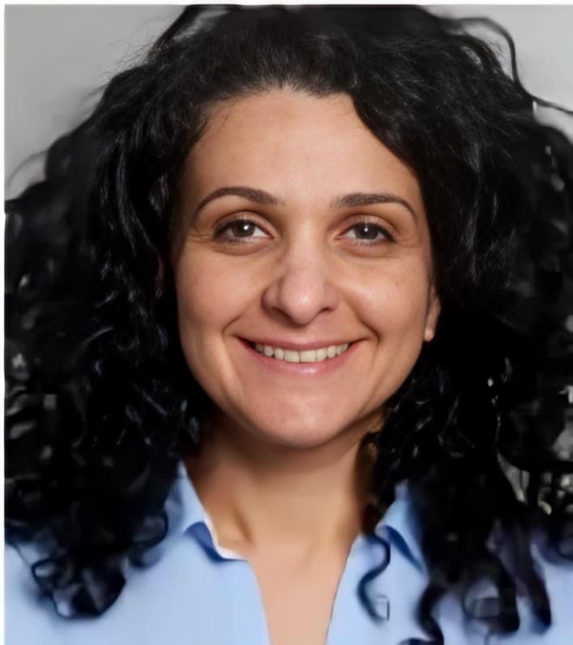
With extensive expertise in automated histochemical image analysis, she facilitates the transition from manual workflows to AI-driven solutions that deliver speed, consistency, and unbiased results. Her core capabilities include advanced marker quantification, scalable image processing, tailored analytic pipelines, and data-driven image curation.
Dr. Eliyahu’s specialized knowledge strengthens ROSEAId’s mission to deliver real-time, high-precision diagnostics. Her hands-on approach and focus on accuracy ensure each analysis is both reliable and actionable, while her adaptable methods support projects ranging from focused studies to large-scale research initiatives. Her contributions will be pivotal in enhancing our histochemical evaluation workflows and scaling ROSEAId’s AI-driven pathology platform, allowing scientists to concentrate on high-impact research.

“Her ability to translate complex imaging into practical, scalable insights and optimize it for real-world use is invaluable as we expand ROSEAId’s research capabilities and clinical applications in telepathology,” said Joseph A. Rossi, Chief Executive Officer of ROSEAId
Dr. Eliyahu advances the next-generation digital pathology by transforming complex imaging data into actionable insight without compromising quality or scalability.
Please join us in welcoming Dr. Efrat Eliyahu to ROSEAId.
About ROSEAId
ROSEAId, Inc- is a health sciences AI based company with advanced technology in telepathology supporting clinical operations and research. Our Platform leverages AI-driven and machine learning models for early cancer detection and monitoring. ROSEAId empowers healthcare professionals with solutions to make more informed decisions while streamlining clinical and scientific workflows. The firm continues to drive innovation in early cancer detection, delivering faster, more accurate solutions to meet healthcare challenges today and into the future.
For media inquiries, contact: Media Relations
Media@roseaid.com
Follow us on LinkedIn | Visit our Website: https://roseaid.com/

